Vol. 12 Issue 5 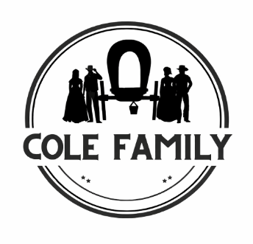 May 2026
COLE FAMILY NEWSLETTER
The Stephen and William Temple Cole Families
92nd Cole Family Reunion

August 8-9, 2026
Schedule of Weekend Activities
Saturday, August 8, 2026
4:00 PM – 9 PM OPEN - Cooper County Fairgrounds Building, 16899 Dunkles Drive, Boonville, Missouri
11:00 - 4:00 PM Come & Go Tours
1:00 PM Brisco Cemetery Brick Dedication
Briscoe Cemetery, 12 Miles South of Boonville, on Highway 5.
Mt. Nebo Cemetery- Rt. E, Turn right after Hannah Cole Park.
Cole Fort Site- 1215 East Morgan Street, Boonville.
Places To Visit in the Area:
Cooper and Howard counties have a rich Cole history. Go here for a list of things to see. https://www.coopercountyhistoricalsociety.org/exploring-the-county
6:00 PM Dinner at the Fairgrounds building (must reserve your meal). This will be a light Buffet-style Dinner, the cost will be $14.00 per person. Chicken Strips, Ham, scalloped potatoes, Cole slaw, Baked Beans, cookies, DQ Dilly Bars. Please reserve your spot by July 25, 2026, by contacting Bob Painter at 816-806-0733 (call or text). bpainter@coleassociation.com. Please pay the night of the dinner with cash or check (no credit cards).
Sunday, August 9, 2026
11:00 AM Reunion Registration at the Cooper County Fairgrounds building
NOON Family Potluck Style Meal at Cooper County Fairgrounds Building.
1:00 PM Family Photo
1:30 Business Meeting followed by announcements.
5:00 PM Fairgrounds Building Closes. Safe travels!!!

Cole Family News
Scholarship Winners

Cole Scholarship Winner- Effie will be attending Stephens College in the Fall to study Nursing. Her accomplishments in sports are amazing. While at Boonville High School, she has lettered in basketball, volleyball, tennis, and set six records in high school track.
Aside from being a gifted athlete, Effie is a member of the National Technical Honor Society, maintains a 3.32 GPA, is on the honor roll, and has earned Academic letters six semesters thus far. She also works part-time as a waitress.

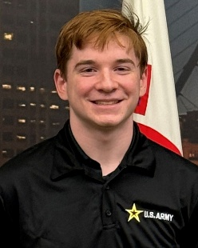
Cole Scholarship Winner- Evan Buchman is a graduate of Grafton High School, Grafton, WI. He will be attending the University of Pittsburgh in the fall, studying Pre-Med with the goal of becoming a trauma surgeon. He has lettered in Track and Cross Country. He is the President of HOSA Future Health Professionals, as well as an Eagle Scout, a member of BlackHawk Crew, and a Freshman Orientation Leader. He works as an Advocate at Aurora Health Care as a certified nursing assistant.

Cemetery News on the Briscoe Cemetery restoration
We are grateful to Mark Jenkins, who, with pride, mows the Cemetery of his ancestors. He keeps it looking very nice.
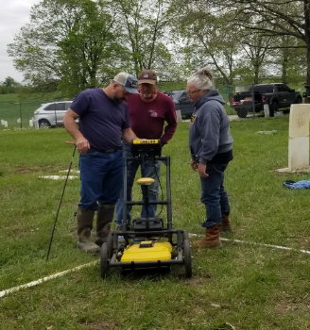
Jackwick Metal Detecting/GPR, Polo, Missouri, has completed the survey and is working on a final report. They are re-scanning certain areas. That report will be sent out when completed.
Bob Painter, PG, continues to repair and put up stones. This will help with unmarked graves and finding stones. All the stones that have been found are now restored.
We are seeking a sign company that can create a storyboard for the cemetery.
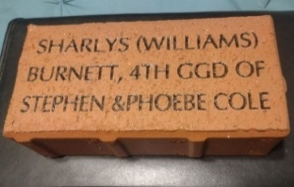
Brick Campaign - Briscoe Cemetery Restoration Project - On Saturday, August 8th, at 1PM, we will hold a Brick Path Dedication. Please join us as those who have purchased bricks will be placing their brick in the pathway.
If you have not ordered a brick and would like to do so, go to www.fundraisingbrick.com/colefamily/ The cost of a brick is $90. This is a great way to honor or memorialize a family member or loved one. To receive a brick by August 8th, bricks must be ordered by June 20th.

New Board Members:
The Bylaws were finished and approved in 2025. It was approved to add two more Board Members.
Velma Cole – has been a big help planning the 90th reunion, silent auction, heritage days, and other events. She is the past President of the Missouri United Daughters of the Confederacy and a member of various historical Societies.
Ray Owens - Is the Cole Family Genealogist. He is a professional Forensic Genealogist. He has loaded all the references from the various Cole Books on Ancestry.com. His website is https://heritagekinnections.com/ .

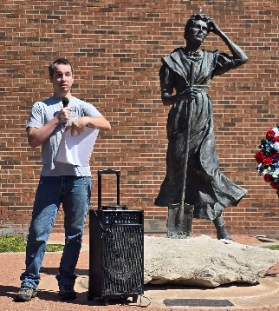
Celebrating Our Revolutionary Heritage
The Hannah Cole Chapter of DAR held its wreath-laying ceremony at Hannah's statue on May 9, 2026. Several Cole family members were in attendance as Ray Owens shared the history of Halbert Allison, Phoebe and Hannah's father. Halbert was a Revolutionary War soldier, serving in the Virginia Militia from Montgomery County, Virginia. Ray’s speech is printed below. Go to the following website to learn more. https://heritagekinnections.com/project/military-exploits-of-halbert-allison/

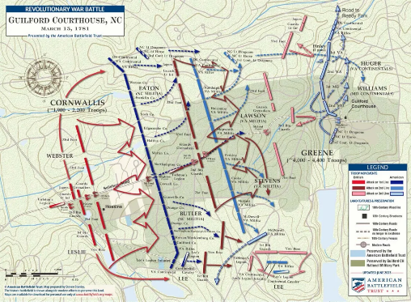
Battle of Gilford Court House- The date was March 15, 1781. Cornwallis had been pushing for a confrontation with Greene’s army for a couple weeks. It all came to a head at Guilford Courthouse.
Hannah and Phoebe’s father, Halbert Allison, was part of the militia from Montgomery County, Virginia, serving under Capt. Frederick Edwards. Edwards’ company was put under the command of Colonel William Preston. Now, Preston had become ill just before the battle took place. So Preston’s militia was therefore funneled in with the militia from Washington County, Virginia, commanded by Colonel William Campbell and accompanied by Colonel Walter Crockett.
The main battle began at about 1:30 in the afternoon. Cornwallis came up the New Camden Road, and Singleton began firing his six-pounder field cannons at the British. General Greene had set up his army in three distinct lines.
Hannah’s father and the rest of the Washington and Montgomery County militias were set up at the very southern end of the 1st line. If you look at the battle map we provided, you’ll see the Virginia rifles directly above where Lt. Col. Lee’s legion and cavalry are positioned. That’s where Halbert Allison was at, and he couldn’t have been in a worse position for what was about to happen.
You see, most of the middle of Greene’s 1st line was made up of multiple companies of North Carolina militia. These militias were not regular soldiers, just everyday men that weren’t experienced in hand-to-hand combat. To make matters worse, the bulk of the 1st line of militia were set up along a split rail fence, providing virtually no cover. General Greene asked these men to fire 2 volleys into the British, by which they could then retire to the 2nd line.
As the British made their initial charge, Colonel Campbell noticed that many of the North Carolina militia had retired through the 2nd line without ever firing a shot, which caused the British to funnel up through the center of the 1st line, pushing Campbell and Lee’s legion away from Greene’s position on the 3rd line, separating them. The few North Carolina militia that did not retreat completely from battle fought with Campbell’s riflemen for the rest of the day.
After being pushed southeast by Major General Leslie with the 71st foot, 1st Battalion Guard, and Von Bose’s Hessians, they were beyond the 2nd and 3rd lines by over half a mile. At this time, Lee, with his cavalry, recalled his infantry and marched north to rejoin General Greene, leaving Campbell and the Virginia riflemen to fend off the Hessians.
Campbell had his men employ a hit-and-run tactic through the heavy woods. They were holding their own until Cornwallis sent Tarleton and his Green Dragoons to disperse Campbell’s riflemen. When Tarleton arrived, Campbell’s men were forced to run. Some were chased and cut down. Ultimately, an infuriated Campbell and his men abandoned the field and rejoined Greene on his retreat from Guilford Courthouse.
After the battle, General Greene wrote to Colonel Campbell saying, “Most of the riflemen having gone home, and not having it in my power to make up another command, you have my permission to return home to your friends.” So they went home.
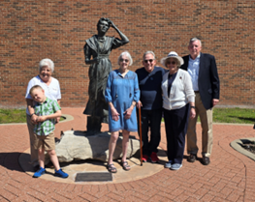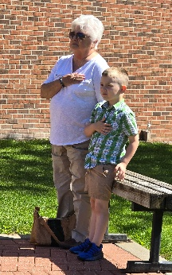

Bennett C. Clark, “Diary of a Journey from Missouri to California in 1849”
(4th installment)
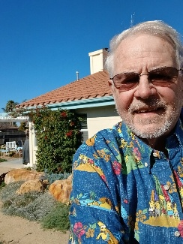
By Will Kastner
The Boonville 49er wagon group, including W.T. Cole, his brother Andrew, and his cousin Mark, had endured the waterless Sublette Cutoff, experienced the sad death of Alfred Corum, and had traveled about 1,000 miles along the Oregon Trail—about halfway to their destination in the California gold fields. The road heading northwest in the southwest corner of (now) Wyoming in early July was hard and the river crossings were difficult, but the grass was more abundant there. The party apparently split into sections again, perhaps because of the relative speeds of the different wagons, some smaller and faster, some larger and heavier. They continued along the Bear River, reaching Soda Springs, (now) Idaho on July 7th and Fort Hall on July 9th.
By mid-July the train had passed through lower Idaho, cut off the very northwest corner of (now) Utah and entered what would become the State of Nevada. Then on “July 18: A party of B.C. Clark, N.C. Peters & Wm T. Cole started forward this morning to Sutters Fort to procure provisions & make a location &c with what provisions they could pack on their riding animals.” This diary entry creates the hard-to-resolve discrepancy that is especially clearly demonstrated in the July 29th entry quoted previously in an earlier Cole family newsletter: “Here our friend Mark [Cole] set to work & effected quite a revolution in our mode of getting along. He so arranged it that when the change was completed no mess was driving its own wagon. . . . Our train is now reduced to 5 wagons including the buggy.” This diary is reputed to have been kept by B. C. Clark: however, while Clark himself clearly left the train on July 18th, the diary writer clearly stayed with the train. Perhaps the simplest explanation is that this diary was not actually kept by B. C. Clark but by a cousin in his family with a different last name.
W.T. and Clark, then, travelled on ahead to California, but the remainder of the party continued to slog their way through familiar hardships: long stretches of desert with neither water nor grass; weak draft animals; heat; heavy sand; steep canyons; frequent and troublesome stream crossings. And with the words “Aug.11.” the diary abruptly ends. I do not know if the writer stopped making entries or if pages have been lost. The Boonville travelers were at that point toward the western edge of Nevada, making their way along the Truckee River, with the terrible deserts behind them but with the steep Sierra Nevadas still ahead.
But there are other sources for this journey and there is more to the story of my great-great-grandfather W. T. Cole. I have copies from the History of the State of California and Biographical Record of the San Joaquin Valley, California: An Historical Story of the State’s Marvelous Growth from Its Earliest Settlement to the Present Time, Containing Biographies of Well-Known Citizens of the Past and Present, by “Prof. J. M. Gunn, A.M., Author of A History of Los Angeles and Vicinity, History of Southern California . . . .” And W. T. Cole just happens to be one of those Well-Known Citizens! Such historical and biographical compilations seem to have been popular at the beginning of the 20th century, extoling the men and women who had built America, then itself debuting on the world stage. (W. T. Cole is found on pages 1483-85 of Gunn’s History. Since W. T. was still alive at the time of its writing, I would like to believe that he was personally consulted about his story:

At Goose creek [probably in very northeastern Nevada] his party left their wagons and mules and proceeded with pack-horses to San Francisco, where he landed August 10th, 1849. . . . After having secured the company’s mail at San Francisco, Mr. Cole returned eastward and met them on the Bear river, near the present site of Nevada City [CA]. With the members of the party, he then proceeded to the vicinity of Johnson’s ranch [the first outpost of civilization on the Overland Emigrant Trail after crossing the Sierras. Near Wheatland, CA, which is about 40 miles north of Sacramento.], where he spent one month in assisting the company to close out its affairs and then made his way to the Yuba river [very significant for gold mining], where he mined until a severe illness and the advice of his physician caused him to seek another location. [Cholera, typhoid, dysentery, scurvy, and pneumonia were rampant among the miners.] Two miles from Sacramento he took up a tract of land, where he embarked in the stock business, and in addition furnished steamers with wood. For a time he was exceedingly prosperous, but all was lost in the floods of 1849 and 1850. After continuing in the stock business there for some years, in 1860 he removed to Fresno county and settled on the Kings river bottom.

Thus concludes what I have been able to find about the actual overland adventure by three young Cole men from Booneville to California in 1849, though there is a little other information:
By late January of 1850 some were returning. Judge Hays of Saline and several others arrived on the S. S. Anna, bringing considerable quantities of dust with them. Abiel Leonard’s brother wrote him from Cooper County that . . . B. C. Clark, Lewis Hutchinson, and John Corum, who had gone out in the spring [in the party with the Coles], had returned the day before. They had all been sick and done nothing in the way of getting gold. It had taken their outfit and what little they dug to pay their expenses. They represented the country as very sickly. But they said there was plenty of gold, and if a man could have his health, he could get gold a plenty.
“Boonslickers in the Gold Rush to California,” Missouri Historical Review, July 1947.
W. T. Cole, however, stayed in California, founding my Cole line here.
Will Kastner (I-1, II-1, III-1, IV-1, V-1, VI-3, VII-4, VIII-4, IX-1, X-6, XI-2, XII-2, XIII-1)

We are so grateful to Will Kastner for this series. We hope he keeps finding more to write.

Frontier Days – Arrow Rock Historic Site, Park, Arrow Rock, MO. The first Annual Pioneer Days will be held on May 30th. Families of the first Pioneers are invited to gather for a day of events at historic Arrow Rock. Descendants of the McMahan, Cole, Cooper, Turley, and Hicklin early pioneer and "fort families" have ALL confirmed their attendance. Tables will be set up for each of these families, but you'll need to bring your own lawn chairs.

Get in touch and tell us a story.
Please send us the email addresses of your family members who did not receive this newsletter. If you receive the newsletter by US Mail and have an email address, please send us your email address. Thank you.
- New Facebook Group: Stephen and William Temple Cole Family. This page allows everyone to post and be involved. We hope you will follow, go there, and tell us a little about yourself. https://www.facebook.com/groups/1272804691587766
- Cole Family Association Facebook: https://www.facebook.com/colefamilyassociation/
- Websites: https://coleassociation.com/ (thank you, John Sage)
- Bob Painter bpainter@coleassociation.com 816-806-0733

See you in August

